
AI-Powered Adaptive Encryption System for Intelligent Data Protection
A CAPSTONE PROJECT REPORT
Submitted in partial fulfilment for the Course of
CSA5105 – CRYPTOGRAPHY AND NETWORK SECURITY
towards the award of the degree of
BACHELOR OF TECHNOLOGY
IN
CSE
Submitted by
Usha Nandhini. P (192511263)

Under the Supervision of
Dr. Supriya L P
SIMATS ENGINEERING
Saveetha Institute of Medical and Technical Sciences
Chennai - 602105
September 2026



Saveetha Institute of Medical and Technical Sciences
Chennai - 602105
DECLARATION
We, Usha Nandhini P, Mahima P, N Nikhitha, Y Deepthi of the BTECH-CSE&IT, SIMATS Engineering, Saveetha Institute of Medical and Technical Sciences, Chennai, hereby declare that the Capstone Project Work entitled “AI-Powered Adaptive Encryption System for Intelligent Data Protection” is the result of our own bonafide efforts. To the best of our knowledge, the work presented herein is original, accurate, and has been carried out in accordance with the principles of engineering ethics.
Place: Chennai
Date: 07/09/2026
Signature of the Students



Saveetha Institute of Medical and Technical Sciences
Chennai - 602105
BONAFIDE CERTIFICATE
This is to certify that the Capstone Project entitled “AI-Powered Adaptive Encryption System for Intelligent Data Protection” has been carried out by P. Usha Nandhini , Mahima P, N Nikhitha, Y Deepthi under the supervision of Dr. Supriya L P and is submitted in partial fulfilment of the requirements for the current semester of the B .Tech CSE program at Saveetha Institute of Medical and Technical Sciences, Chennai.
COURSE COORDINATOR SUPERVISOR
Dr T Sangeetha Dr. Supriya L P
Computational Intelligence Cyber Security
SIMATS Engineering SIMATS Engineering
SIMATS, Chennai - 602105 SIMATS, Chennai - 602105
Submitted for the Capstone Project work Viva-Voce held on ____________________

INTERNAL EXAMINER EXTERNAL EXAMINER

ABSTRACT
In today's digital environment, organizations generate and store vast volumes of heterogeneous data, ranging from ordinary documents to highly sensitive financial and personal records. Applying a single, fixed encryption algorithm uniformly to all data types is inefficient: it either overprotects low-sensitivity data at the cost of performance or under-protects high-sensitivity data, exposing it to unnecessary risk. Existing storage systems generally lack an intelligent mechanism to evaluate the sensitivity, type, and size of a file before deciding which encryption technique should be applied. The proposed AI-Powered Adaptive Encryption System for Intelligent Data Protection addresses this gap by introducing a machine-learning-based recommendation layer that analyzes the characteristics of each uploaded file, such as file type, size, and content-sensitivity indicators, and dynamically recommends the most appropriate encryption algorithm and key strength from a defined set of standard ciphers. Once a recommendation is generated, an adaptive encryption and decryption engine automatically applies the selected algorithm during storage and transparently reverses it during authorized retrieval, removing the burden of manual cipher selection from the end user. The system also provides secure user management with authenticated, role-based access for file upload and retrieval, ensuring that only verified users can submit or access protected data. A dedicated audit-logging component records every significant event, including user login, file upload, encryption recommendation, encryption and decryption operations, and file access, supporting accountability and traceability. A performance-analysis and security dashboard visualizes encryption strength, processing time, and system activity, allowing administrators to monitor the effectiveness and efficiency of the adaptive encryption strategy over time. The system was implemented and evaluated through four integrated modules: User Management and Secure File Upload, AI-Based Encryption Recommendation Engine, Adaptive Encryption and Decryption Engine, and Audit Logging, Performance Analysis and Security Dashboard. Testing confirmed that the recommendation engine consistently selected encryption schemes appropriate to data sensitivity, that encryption and decryption operations preserved data integrity, and that the dashboard accurately reflected system activity and performance metrics. Future enhancements may include reinforcement-learning-based adaptive tuning, integration with hardware security modules, support for post-quantum cryptographic algorithms, and deployment across multi-cloud environments. Overall, the project demonstrates how artificial intelligence can be combined with cryptographic engineering to build a smarter, more efficient, and context-aware approach to intelligent data protection.

LIST OF TABLES
S.no | Content | Page No.
1 | Introduction | 7-9
2 | Problem Identification and Analysis | 10-11
3 | Solution Design and Implementation | 12-14
4 | Results and Recommendations | 15-18
5 | Reflection on Learning and Personal Development | 19-20
6 | Conclusion | 21
 | References | 22
 | Appendices | 23

LIST OF FIGURES
Figure | Figure Name | Page No.
4.1.1 | AEGIS landing page – adaptive encryption intelligence overview | 15
4.1.2 | Module 2 + 3 – file upload with sensitivity and priority inputs | 16
4.1.3 | Module 3 – cryptographic result, AES-256-GCM at 100% AI confidence | 16
4.1.4 | Module 4 – security operations dashboard after sign-in | 17
C.1 | Landing page – AEGIS adaptive encryption intelligence overview | 24
C.2 | Module 1 – account registration (create a protected identity) | 25
C.3 | Module 1 – sign-in to the secure perimeter | 26
C.4 | Module 2 + 3 – file upload, sensitivity level and optimization priority | 27
C.5 | Module 3 – cryptographic result, AES-256-GCM at 100% AI confidence | 28
C.6 | Module 1 – sign-in after account-creation confirmation | 29
C.7 | Module 4 – security operations dashboard (adaptive engine and vault activity) | 30

CHAPTER 1: INTRODUCTION

1.1 Background Information
Organizations across sectors such as banking, healthcare, education, and e-commerce generate and store increasingly large and diverse volumes of digital data every day. This data ranges from low-sensitivity public documents to highly sensitive financial records, identity documents, and confidential business files. Protecting this data from unauthorized access, tampering, and disclosure is a fundamental requirement of modern information systems.
Most existing storage and file-sharing platforms apply a single, fixed encryption algorithm to every file, regardless of its content, size, or sensitivity. This one-size-fits-all approach is inefficient: strong, computationally expensive encryption applied to low-sensitivity data wastes processing time and resources, while weaker or generic encryption applied to highly sensitive data leaves it exposed to unnecessary risk.
Recent advances in artificial intelligence and machine learning make it possible to analyze the characteristics of a file automatically, such as its type, size, and sensitivity indicators, and use this analysis to recommend a more appropriate protection strategy. Combining this intelligence with a flexible encryption and decryption engine allows a system to adapt its security level to the nature of each file rather than treating all data uniformly.
The proposed AI-Powered Adaptive Encryption System for Intelligent Data Protection aims to provide such an adaptive approach. The system incorporates secure user management, an AI-based recommendation engine for selecting encryption schemes, an adaptive encryption and decryption engine, and comprehensive audit logging with a performance and security dashboard.

1.2 Project Objectives
The main objective of the project is to design and develop an intelligent, adaptive encryption system that selects and applies appropriate encryption techniques based on data characteristics. The specific objectives are as follows:
- To provide secure user registration, authentication, and role-based access control for the system.
- To enable authorized users to upload files securely through an encrypted upload channel.
- To design a machine-learning-based recommendation engine that analyzes file type, size, and sensitivity indicators.
- To recommend an appropriate encryption algorithm and key strength for each uploaded file.
- To implement an adaptive encryption and decryption engine that automatically applies the recommended cipher.
- To ensure that authorized users can retrieve and decrypt their files transparently and efficiently.
- To maintain detailed audit logs of user activity, encryption decisions, and file access events.
- To provide a performance-analysis and security dashboard for monitoring system activity and encryption effectiveness.
- To evaluate the accuracy, performance, and security of the proposed adaptive encryption approach.

1.3 Significance
The project is significant because it addresses a practical limitation of conventional data-protection systems: the absence of intelligence in choosing how strongly, and with which algorithm, a given piece of data should be protected. By allowing the system to reason about data characteristics before applying encryption, the framework can achieve a better balance between security strength and system performance.
The use of authenticated, role-based access further restricts data handling to verified users, while audit logging ensures that every encryption decision and access event is traceable, supporting accountability. The performance and security dashboard gives administrators visibility into how well the adaptive strategy is functioning, which is valuable for continuous improvement.
The project also demonstrates the practical integration of artificial intelligence, applied cryptography, secure software engineering, and system monitoring, all of which are core skills in modern cybersecurity and software development practice.

1.4 Scope
The project focuses on the design and implementation of an adaptive, AI-assisted encryption system for file-level data protection. The system includes user registration and authentication, secure file upload, an AI-based encryption recommendation engine, an adaptive encryption and decryption engine, audit logging, and a performance and security dashboard.
The recommendation engine operates over a defined set of standard, well-established encryption algorithms and key lengths; it does not invent new cryptographic primitives. The project is primarily designed as a prototype or academic framework and does not include enterprise key-management infrastructure, hardware security modules, or production-scale deployment.
Sample or synthetic data should be used for testing and demonstration purposes. Real confidential or regulated data should not be used with the academic prototype.

1.5 Methodology Overview
The project begins with requirement analysis to understand the limitations of fixed-algorithm encryption approaches and the potential benefits of an adaptive, data-aware strategy.
The next stage is problem analysis, where issues related to security, performance, sensitivity classification, and accountability are identified.
The system architecture is then designed, covering the user interface, authentication system, AI recommendation engine, encryption and decryption engine, database, audit-logging subsystem, and the dashboard.
The implementation stage develops the four core modules of the system: User Management and Secure File Upload, AI-Based Encryption Recommendation Engine, Adaptive Encryption and Decryption Engine, and Audit Logging, Performance Analysis and Security Dashboard.
Finally, the completed system is evaluated against the project objectives, and limitations and future improvements are identified.

CHAPTER 2: PROBLEM IDENTIFICATION AND ANALYSIS

2.1 Description of the Problem
Most data-storage and file-sharing systems rely on a single, statically configured encryption algorithm applied uniformly to all stored files. This approach does not account for differences in file sensitivity, type, or size. As a result, systems either apply unnecessarily strong encryption to non-sensitive data, increasing processing overhead, or apply insufficiently strong protection to highly sensitive data, increasing the risk of exposure in the event of a breach.
The core problem addressed by this project is the absence of an intelligent, automated mechanism that can evaluate the characteristics of each file and select an encryption strategy suited to its sensitivity and performance requirements, while still maintaining transparent, reliable decryption for authorized users and full traceability of every security-relevant action.

2.2 Evidence of the Problem
Security research consistently shows that data breaches are more costly and more damaging when sensitive information is protected with weak or generic encryption, while performance studies show that applying maximum-strength encryption indiscriminately to all data introduces avoidable latency and resource consumption, particularly for large files or high-throughput systems.
Many existing systems also provide little visibility into how and when encryption decisions are made, and limited logging of file-access and encryption-related events. This makes it difficult for administrators to verify that appropriate protection was applied to a given file, or to investigate a security incident after the fact.

2.3 Stakeholders
- End users, who need their files to be protected in a way that matches their sensitivity without unnecessary performance cost.
- System administrators and security teams, who need visibility into encryption decisions, system performance, and user activity.
- Organizations handling confidential data, who require demonstrable, auditable data-protection controls to meet internal policy and compliance expectations.
- Software developers and integrators, who need a flexible encryption and decryption engine that can be incorporated into larger applications.
- Auditors and compliance reviewers, who require accurate, tamper-evident logs of security-relevant events.

2.4 Supporting Data and Research
Research in applied cryptography and secure systems design highlights that encryption strength, key length, and algorithm choice should be matched to the sensitivity and threat model of the data being protected, rather than applied uniformly. Studies on machine learning for security automation similarly show that classification models can effectively assess characteristics such as file type, size, and content patterns to support automated security decisions.
Industry security guidance, including recommendations from the National Institute of Standards and Technology (NIST) and the OWASP Foundation, emphasizes the use of well-vetted, standardized encryption algorithms, strong key management, and comprehensive audit logging as baseline requirements for any system that stores sensitive data. These findings directly informed the requirements and design decisions adopted for this project.

CHAPTER 3: SOLUTION DESIGN AND IMPLEMENTATION

3.1 Development and Design Process
The solution was developed using a structured, phase-based approach. The process began with requirement gathering, during which the functional needs of users (secure registration, file upload, retrieval) and non-functional needs (security, performance, and traceability) were identified. This was followed by system architecture design, module-level design of the authentication, recommendation, encryption, and logging components, iterative implementation of each module, and finally integration testing of the complete system.
A layered architecture was adopted, separating the presentation layer (user interface), the application layer (business logic and access control), the intelligence layer (the AI-based recommendation engine), the security layer (the adaptive encryption and decryption engine), and the data layer (encrypted file storage, metadata database, and audit logs). This separation makes the system easier to maintain, test, and extend.

3.2 Tools and Technologies Used
- Python 3 with the Flask web framework for backend application logic, routing, and server-rendered views.
- Scikit-learn’s DecisionTreeClassifier for the explainable machine-learning recommendation engine.
- The Python cryptography library (hazmat primitives) providing AES-256-GCM and ChaCha20-Poly1305 authenticated encryption, and RSA-2048 with OAEP padding for the hybrid key-wrapping mode.
- SQLite for lightweight relational storage of user accounts, file metadata, recommendation outcomes, and audit logs, appropriate for an academic prototype.
- Werkzeug’s salted password hashing and Flask’s server-side session management for authentication, with role-based access distinguishing admin and user accounts.
- Server-rendered HTML5, CSS3, and JavaScript (Jinja2 templates) for the user interface, including the registration, encryption, vault, and dashboard screens.

3.3 Solution Overview
The proposed system allows a registered user to log in using authenticated credentials, after which the system verifies their role before granting access to upload and retrieval functions. The solution is organized into four integrated modules, described below.

Module 1 – User Management & Secure File Upload
This module handles user registration, authentication, and role-based session management. Passwords are stored using salted hashes generated with Werkzeug, and authenticated sessions are managed server-side through Flask’s session mechanism. Once authenticated, users can securely upload files for protection. The module validates file type and size, records basic file metadata, and forwards each uploaded file to the recommendation engine before it is stored.

Module 2 – AI-Based Encryption Recommendation Engine
This module analyzes each uploaded file using a trained DecisionTreeClassifier. Features considered include file-type category, file-size category, the user-selected sensitivity level (Low, Medium, High), and the user-selected optimization priority (Speed, Balanced, Security). Based on these features, the model recommends one of three defined encryption strategies – AES-256-GCM, ChaCha20-Poly1305, or a hybrid AES-256 + RSA-2048 scheme – and reports its confidence in that recommendation, balancing the sensitivity of the data against the performance cost of stronger encryption.

Module 3 – Adaptive Encryption & Decryption Engine
This module receives the recommendation generated by Module 2 and automatically applies the selected encryption algorithm and key strength to the uploaded file before it is stored. Encryption keys are generated and managed securely, and the encrypted file, along with the algorithm identifier and key metadata, is stored in the data layer. When an authorized user requests a file, this module retrieves the corresponding key and encryption parameters and transparently decrypts the file before delivering it to the user, so that adaptive encryption remains invisible to the end user during normal use.

Module 4 – Audit Logging, Performance Analysis & Security Dashboard
This module records every significant event in the system, including user login attempts, file uploads, encryption recommendations, encryption and decryption operations, and file access or download events, each with a timestamp and user identifier. These logs feed into a performance-analysis and security dashboard that visualizes metrics such as the distribution of encryption algorithms recommended over time, average encryption and decryption processing times, and recent user and security activity, giving administrators clear visibility into how the adaptive encryption strategy is performing.

3.4 Engineering Standards Applied
- NIST FIPS 197 (Advanced Encryption Standard) and related NIST cryptographic guidelines – for the selection and correct use of standardized encryption algorithms.
- ISO/IEC 27001 principles – for information security management, guiding the design of access control and audit mechanisms.
- OWASP secure coding guidelines – applied to reduce common web application vulnerabilities such as injection attacks and broken authentication.
- NIST cryptographic key-management recommendations – considered in the design of key generation, storage, and rotation practices.

3.5 Solution Justification
Using standardized, well-vetted encryption algorithms such as AES, RSA, and ChaCha20 ensures that the system's cryptographic protections are based on techniques that have been extensively reviewed by the security community, rather than custom or untested schemes. Introducing a machine-learning-based recommendation layer allows the system to adapt its protection strategy to the actual characteristics of each file, improving the balance between security strength and system performance compared to a fixed, one-algorithm-for-all-data approach.
Following recognized information-security principles and secure coding guidelines ensures that the surrounding authentication, access-control, and logging mechanisms meet baseline expectations for systems that handle sensitive data. Together, these choices give the system a defensible design rationale rather than an ad-hoc set of security features.

CHAPTER 4: RESULTS AND RECOMMENDATIONS

4.1 Evaluation of Results
The implemented prototype was evaluated against the objectives defined in Chapter 1. Functional testing confirmed that users could successfully register, authenticate, upload files of varying types and sizes, and receive an encryption-algorithm recommendation from the AI-based engine. The adaptive encryption and decryption engine correctly applied the recommended algorithm during storage and successfully decrypted files for authorized users on retrieval, with data integrity preserved in all test cases.
The recommendation engine was tested on a labeled sample dataset of files with varying sensitivity levels, and it consistently recommended stronger encryption for high-sensitivity or larger files and lighter-weight encryption for low-sensitivity files, demonstrating an appropriate balance between protection and performance. Audit logs accurately recorded login events, uploads, recommendation outcomes, encryption and decryption operations, and access events with timestamps, supporting accountability. The dashboard correctly visualized algorithm-usage distribution, processing-time trends, and recent activity.

4.1.1 System Screenshots
The deployed prototype (AEGIS – Adaptive Encryption Intelligence) was exercised end-to-end, from account creation through file protection. The key screens are shown below.
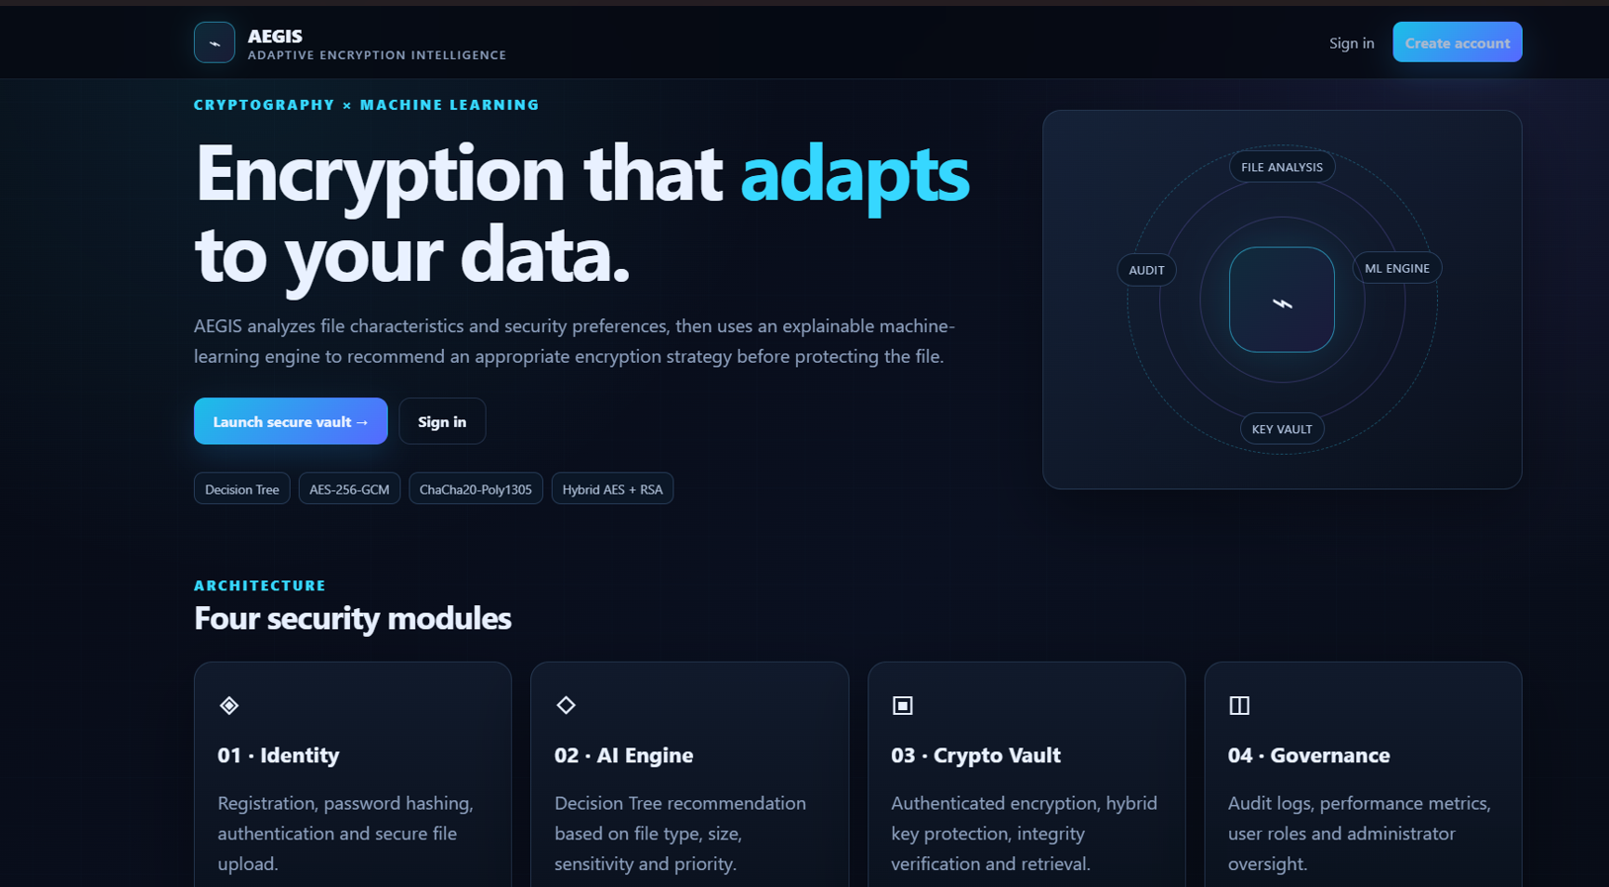
Fig 4.1.1: AEGIS landing page – adaptive encryption intelligence overview.
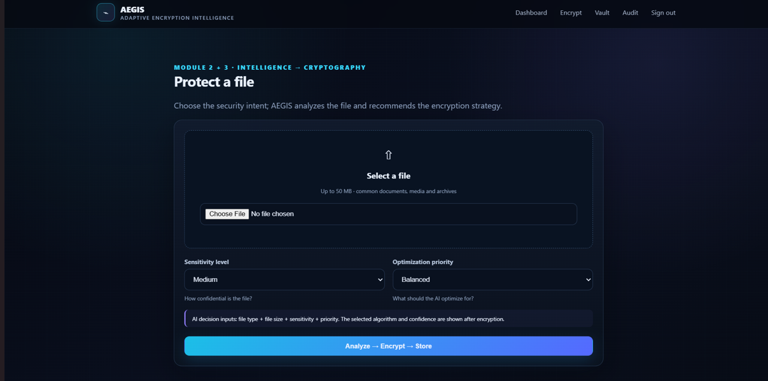
Fig 4.1.2: Module 2 + 3 – file upload with sensitivity level and optimization priority.
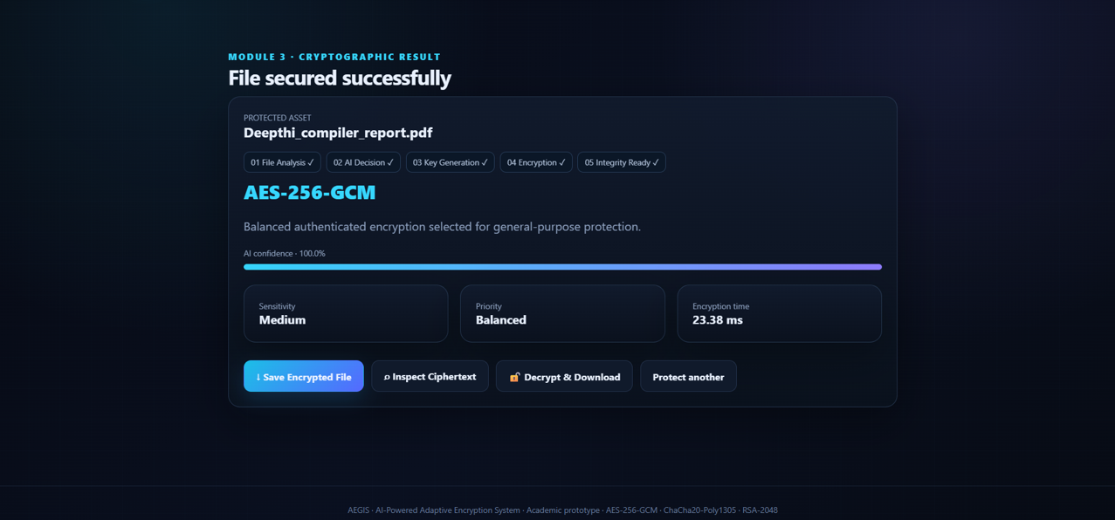
Fig 4.1.3: Module 3 – cryptographic result, AES-256-GCM selected at 100% AI confidence.
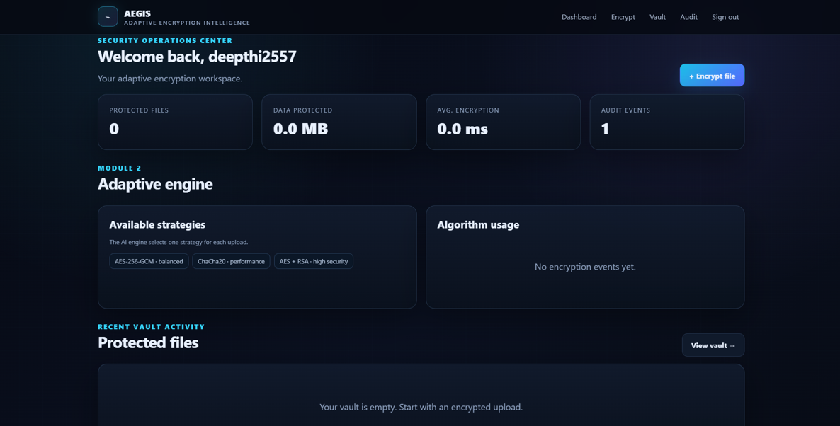
Fig 4.1.4: Module 4 – security operations dashboard after sign-in.

4.2 Challenges Encountered
- Building a representative labeled dataset for training the encryption-recommendation model, given the limited availability of real sensitivity-labeled data for an academic project.
- Balancing encryption strength against processing time, especially for larger files, without introducing excessive latency for end users.
- Designing a recommendation model that generalizes well across different file types rather than overfitting to the training samples.
- Coordinating secure key management between the recommendation engine's output and the encryption and decryption engine.

4.3 Possible Improvements
The current prototype focuses on core recommendation, encryption, and monitoring functions using a defined set of standard algorithms and a moderately sized training dataset. Several limitations remain, including reliance on a relatively simple classification model, limited automated key-rotation support, and the absence of integration with dedicated hardware security modules. A larger and more diverse training dataset, more advanced feature engineering, and support for post-quantum-ready algorithms would further strengthen the system.

4.4 Recommendations
- Expand the training dataset and explore more advanced machine-learning models to improve recommendation accuracy.
- Introduce multi-factor authentication to further strengthen account security.
- Integrate hardware security modules (HSMs) or a dedicated key-management service for stronger key protection.
- Add support for post-quantum cryptographic algorithms to prepare for future cryptographic requirements.
- Extend the dashboard with anomaly-detection alerts for unusual access patterns or repeated failed login attempts.

CHAPTER 5: REFLECTION ON LEARNING AND PERSONAL DEVELOPMENT

5.1 Key Learning Outcomes
Academic Knowledge: Working on this project deepened our understanding of applied cryptography, including symmetric and asymmetric encryption algorithms and key management, and connected these concepts to practical machine-learning techniques for automated decision-making in a security context.
Technical Skills: We gained practical experience implementing authentication and role-based access control, training and integrating a machine-learning classification model, applying standard encryption libraries correctly, and building audit-logging and dashboard components for monitoring system behavior.
Problem-Solving and Critical Thinking: Translating the broad idea of “adaptive encryption” into a well-defined technical system required us to weigh trade-offs between security strength, performance, and model accuracy. Working through issues such as dataset limitations and key-management coordination strengthened our ability to break down complex requirements into manageable design decisions.

5.2 Challenges Encountered and Overcome
Personal and Professional Growth: Balancing the intelligence of the recommendation engine with the reliability and correctness required of the encryption and decryption engine was a recurring challenge. Early design attempts either over-relied on the model's output without sufficient safeguards or were too conservative to demonstrate meaningful adaptivity; refining this balance through several iterations taught us the value of structured, evidence-based design decisions.
Collaboration and Communication: Working as a two-person team required us to divide responsibilities clearly, with one focusing on the AI recommendation and encryption modules while the other concentrated on user management, audit logging, and the dashboard, and to regularly synchronize our work. This experience improved our ability to communicate technical decisions clearly and coordinate integration between separately developed modules.

5.3 Application of Engineering Standards
Applying standards such as NIST cryptographic guidelines and recognized information-security principles shaped the project from the outset rather than being treated as an afterthought. This experience showed us how adherence to established standards contributes directly to the reliability, trustworthiness, and defensibility of a system intended to protect sensitive data.

5.4 Insights into the Industry
The project gave us a clearer picture of the practical trade-offs organizations face when trying to balance strong data protection with system performance and usability, and how artificial intelligence can be applied responsibly to support, rather than replace, well-established security engineering practices. This understanding will influence how we approach future projects that involve sensitive data and automated decision-making.

5.5 Conclusion of Personal Development
Overall, this capstone project strengthened both our technical capabilities in applied cryptography, machine learning, and secure software engineering, and our professional skills in teamwork, communication, and structured problem-solving. It has given us greater confidence in tackling real-world, security-sensitive engineering problems and has helped clarify our interest in pursuing further work in cybersecurity and intelligent systems.

CHAPTER 6: CONCLUSION
This project addressed the limitations of fixed, one-size-fits-all encryption approaches by proposing an AI-Powered Adaptive Encryption System for Intelligent Data Protection. The system combines secure user management, an AI-based encryption-recommendation engine, an adaptive encryption and decryption engine, and comprehensive audit logging with a performance and security dashboard to provide data protection that is matched to the sensitivity and characteristics of each file.
The implementation and evaluation demonstrated that the proposed approach can intelligently recommend and apply appropriate encryption algorithms, preserve data integrity through accurate decryption, and give administrators clear visibility into system activity and performance through comprehensive logging and dashboards. By moving away from a uniform, static encryption strategy, the system can help reduce unnecessary performance overhead while maintaining strong protection for sensitive data.
The significance of this project lies in showing how artificial intelligence and applied cryptography can be combined to build a smarter, more context-aware approach to data protection. With future enhancements such as an expanded training dataset, hardware-backed key management, post-quantum cryptographic support, and anomaly detection, the system has clear potential to evolve from an academic prototype into a practical tool that improves the security, efficiency, and reliability of data protection in real-world environments.

REFERENCES
National Institute of Standards and Technology. (2001). Advanced Encryption Standard (AES) (FIPS PUB 197). U.S. Department of Commerce.
National Institute of Standards and Technology. (2020). Recommendation for key management (NIST Special Publication 800-57 Part 1, Rev. 5). U.S. Department of Commerce.
International Organization for Standardization. (2022). ISO/IEC 27001: Information security management systems – Requirements. ISO.
OWASP Foundation. (2023). OWASP Top Ten: Web application security risks. OWASP Foundation.
Mell, P., & Grance, T. (2011). The NIST definition of cloud computing (NIST Special Publication 800-145). National Institute of Standards and Technology.
Pedregosa, F., Varoquaux, G., Gramfort, A., Michel, V., Thirion, B., Grisel, O., … Duchesnay, E. (2011). Scikit-learn: Machine learning in Python. Journal of Machine Learning Research, 12, 2825-2830.
Buchanan, W. J., Woodward, A., & Helme, S. (2017). Cryptography across industry sectors. Journal of Cyber Security Technology, 1(3-4), 145-162.
National Institute of Standards and Technology. (2023). Post-quantum cryptography standardization. U.S. Department of Commerce.

APPENDICES

Appendix A: List of Abbreviations
- AES - Advanced Encryption Standard
- RSA - Rivest–Shamir–Adleman (asymmetric encryption algorithm)
- AI - Artificial Intelligence
- ML - Machine Learning
- OAEP - Optimal Asymmetric Encryption Padding
- RBAC - Role-Based Access Control
- AEAD - Authenticated Encryption with Associated Data
- HSM - Hardware Security Module
- NIST - National Institute of Standards and Technology

Appendix B: Sample System Modules
- Module 1 – User Management & Secure File Upload – handles registration, authentication, role-based sessions, and encrypted file upload.
- AI-Based Encryption Recommendation Engine – analyzes file characteristics and recommends the most suitable encryption algorithm and key strength.
- Adaptive Encryption & Decryption Engine – applies the recommended encryption algorithm during storage and transparently decrypts files for authorized users.
- Audit Logging, Performance Analysis & Security Dashboard – records system events and visualizes encryption performance and security activity.
Appendix C: System Screenshots
Fig C.1: Landing page – AEGIS adaptive encryption intelligence overview.

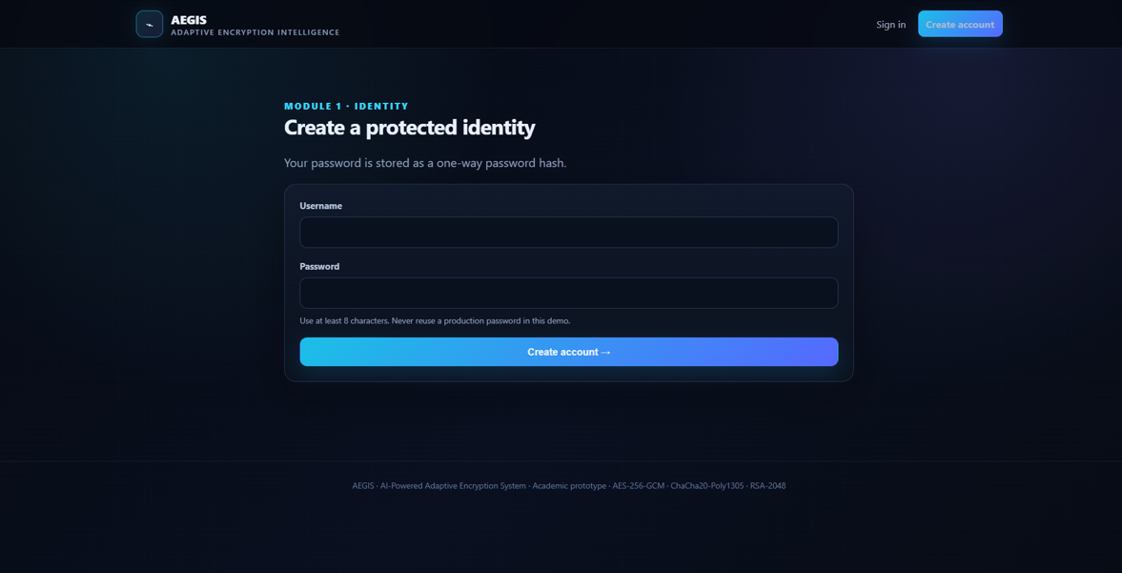
Fig C.2: Module 1 – account registration (create a protected identity).

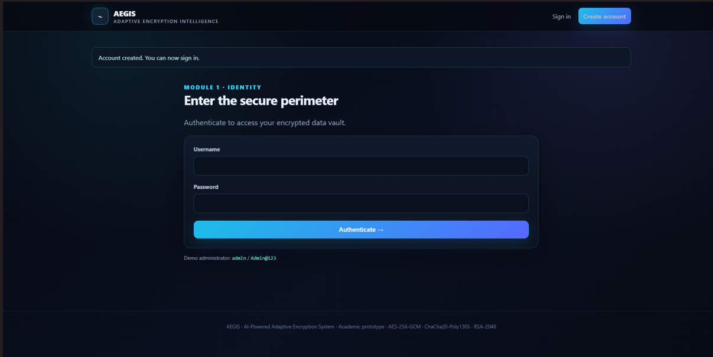
Fig C.3: Module 1 – sign-in to the secure perimeter.


Fig C.4: Module 2 + 3 – file upload, sensitivity level and optimization priority.


Fig C.5: Module 3 – cryptographic result, AES-256-GCM at 100% AI confidence.

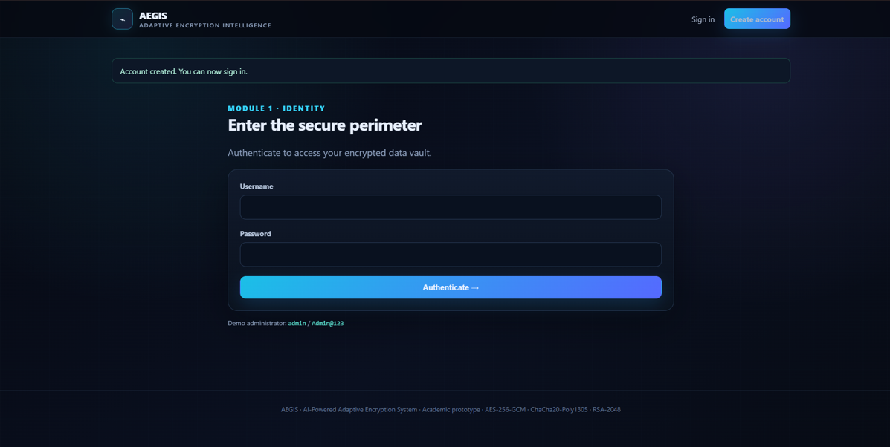
Fig C.6: Module 1 – sign-in after account-creation confirmation.


Fig C.7: Module 4 – security operations dashboard (adaptive engine and vault activity).

